Github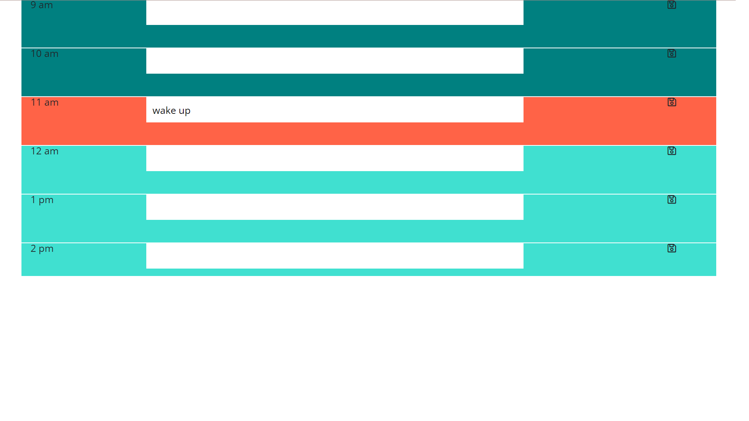

Github link: <https://github.com/carooflee/WorkDayScheduler>

Deployed link: <https://carooflee.github.io/WorkDayScheduler/>

Description:

This project is an interactive workday scheduler. You may enter tasks into each hour and save them for later by clicking the floppy disk icon; they will be saved via local storage and may be deleted at any point as well. The hours are color-coded by past (teal), present (tomato), and future (turquoise), and update automatically based on the current time. Like it’s creator, it is mostly functional and has a questionable aesthetic.